**Lab 09-Creating a chatbot with custom data using Azure OpenAI Service**

**Introduction:**

Azure OpenAI on your data works with OpenAI's powerful ChatGPT (gpt-35-turbo) and GPT-4 language models, enabling them to provide responses based on your data. You can access Azure OpenAI on your data using a REST API or the web-based interface in the [Azure OpenAI Studio](https://oai.azure.com/) to create a solution that connects to your data to enable an enhanced chat experience.

One of the key features of Azure OpenAI on your data is its ability to retrieve and utilize data in a way that enhances the model's output. Azure OpenAI on your data, together with Azure Cognitive Search, determines what data to retrieve from the designated data source based on the user input and provided conversation history. This data is then augmented and resubmitted as a prompt to the OpenAI model, with retrieved information being appended to the original prompt. Although retrieved data is being appended to the prompt, the resulting input is still processed by the model like any other prompt. Once the data has been retrieved and the prompt has been submitted to the model, the model uses this information to provide a completion.

**Objectives**

* To create a storage account, container, and Azure cognitive search service in the Azure portal.
* To deploy gpt-3-turbo and Embedded model in Azure AI Studio and to add data in Chat Playground.
* To test Assistant setup in Chat playground by sending queries in chat session.
* To launch a new power virtual agent and start a conversation with the bot
* To launch a new app and start a conversation with the chatbot.
* To delete gpt-3-turbo and embedded model, Azure storage account, cognitive search service, and the new web app.

**Exercise 1- Create an Azure Storage Account and Azure cognitive Search by using the portal**

**Task 1: Cognitive Services Usages Reader for the Azure OpenAI resource**

1. Open your browser, navigate to the address bar, and type or paste the following URL: https://portal.azure.com/, then press the **Enter** button.

1. In the **Microsoft Azure** window, use the **User Credentials** to login to Azure.

1. Then, enter the password and click on the **Sign in** button.

1. In **Stay signed in**? window, click on the **Yes** button.

1. Type in Subscriptions in the search bar and select **Subscriptions**.

1. Click on your assigned **subscription**.

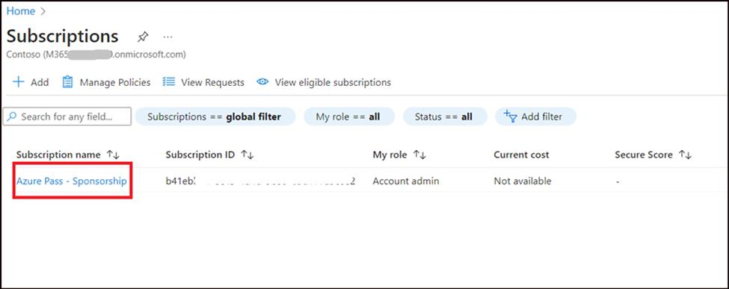

1. From the left menu, click on the **Access control(IAM)**.

1. On the Access control(IAM) page, Click **+Add** and select **Add role assignments**.

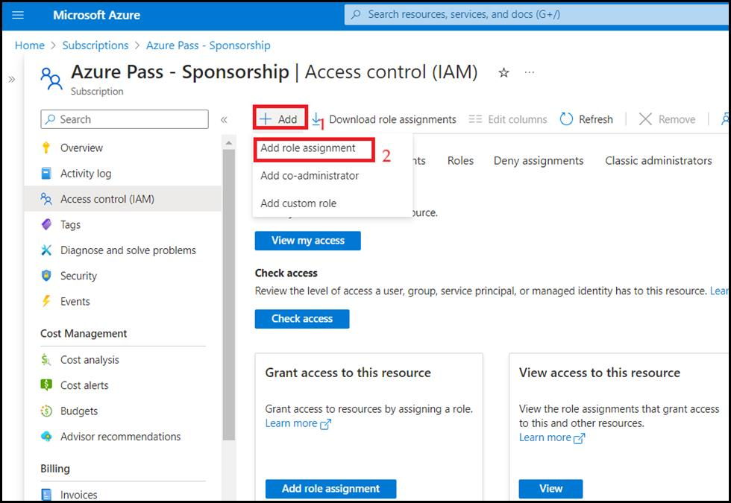

1. Type the **Cognitive Services Usages Reader** in the search box and select it. Click **Next**

1. In the **Add role assignment** tab, select Assign access to User group or service principal. Under Members, click **+Select members**

1. On the Select members tab , search your Azure username and click **Select**.

1. In the **Add role assignment** page, Click **Review + Assign**, you will get a notification once the role assignment is complete.

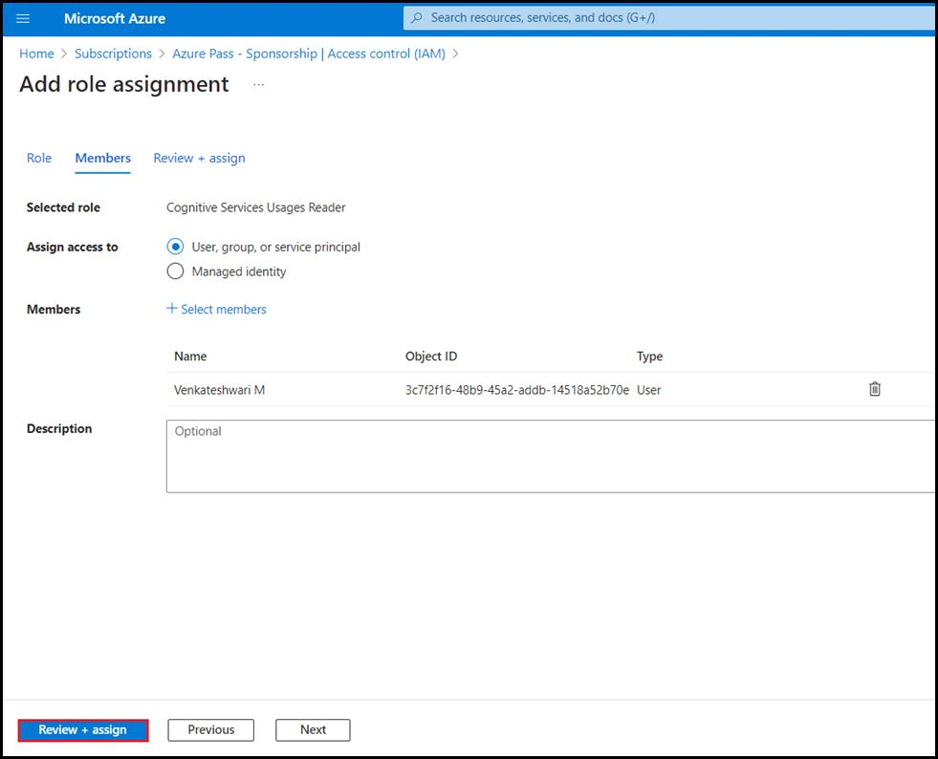

1. You will see a notification – added as Cognitive Services Usage Reader for Azure Pass-Sponsorship.

1. In Azure subscription page from the left menu, click on the **Access control(IAM)**.

1. On the Access control(IAM) page, Click **+Add** and select **Add role assignments**.

1. Type the **Cognitive Services Contributor** in the search box and select it. Click **Next**

1. In the **Add role assignment** tab, select Assign access to User group or service principal. Under Members, click **+Select members**

1. On the Select members tab , search your Azure username and click Select.

1. In the **Add role assignment** page, Click **Review + Assign**, you will get a notification once the role assignment is complete.

1. You will see a notification – added as Cognitive Services Usage Reader for Azure Pass-Sponsorship.

1. Go back to Azure portal home page, type in **Azure OpenAI** in the search bar and select **Azure OpenAI**.

1. Click on your **Azure OpenAI** service.

1. From the left menu, click on the **Access control(IAM)**.

1. On the Access control(IAM) page, Click **+Add** and select **Add role assignments**.

1. Type the **Cognitive Services Contributor** in the search box and select it. Click Next

1. In the **Add role assignment** tab, select Assign access to User group or service principal. Under Members, click **+Select members**

1. On the Select members tab , search for your Azure username and click **Select**.

1. In the **Add role assignment** page, Click **Review + Assign**, you will get a notification once the role assignment is complete.

1. You will see a notification – added as Cognitive Services Usage Reader for Azure Pass-Sponsorship.

**Task 2: Create an Azure Storage Account by using the portal**

1. Sign in to the **https://portal.azure.com/**
2. Click on the **Portal Menu**, then select **+ Create a resource**

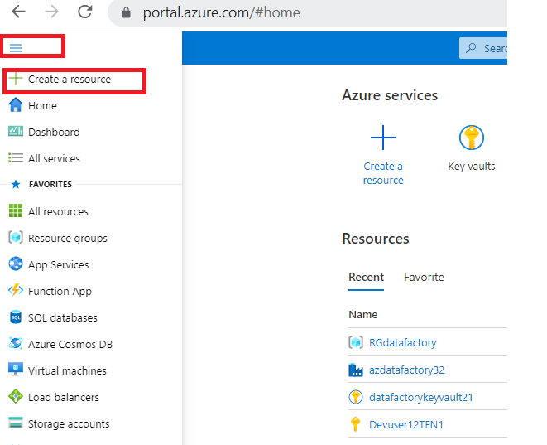

1. In the **Create a resource** window search box, type **Storage account** and then click on the **storage account**.

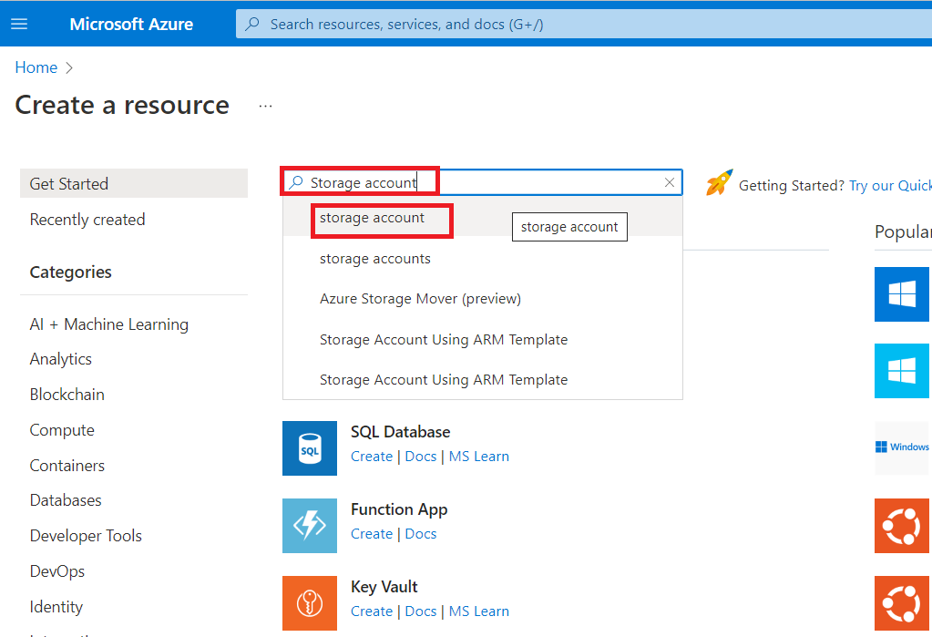

1. In the **Marketplace** page, click on the **Storage account** section.

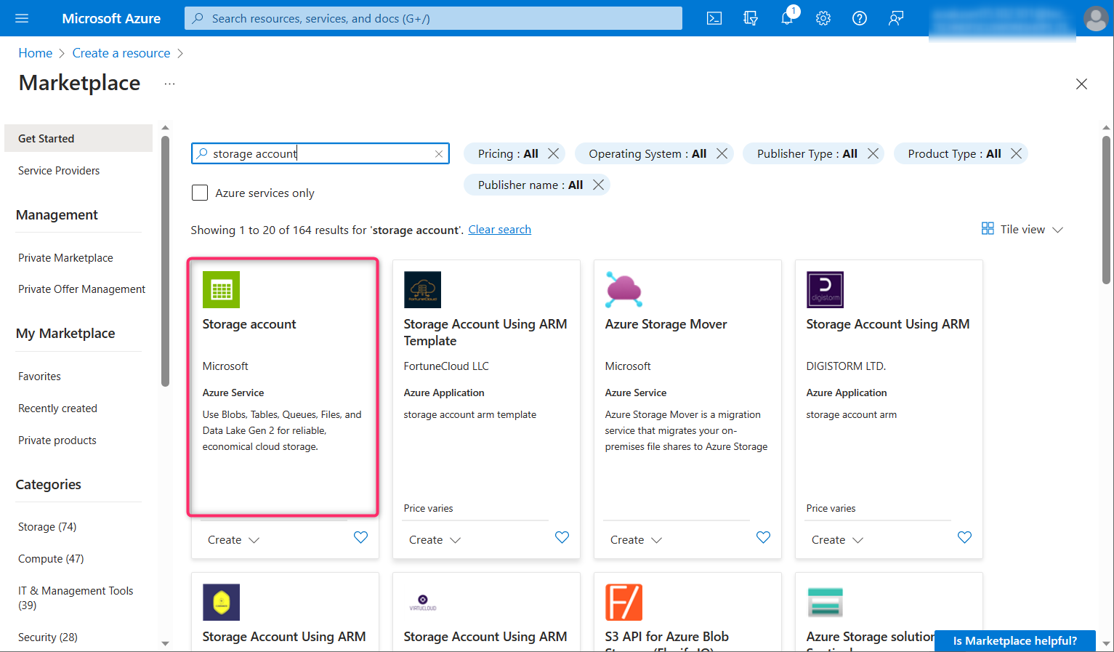

1. In the **Storage account** window, click on the **Create** button.

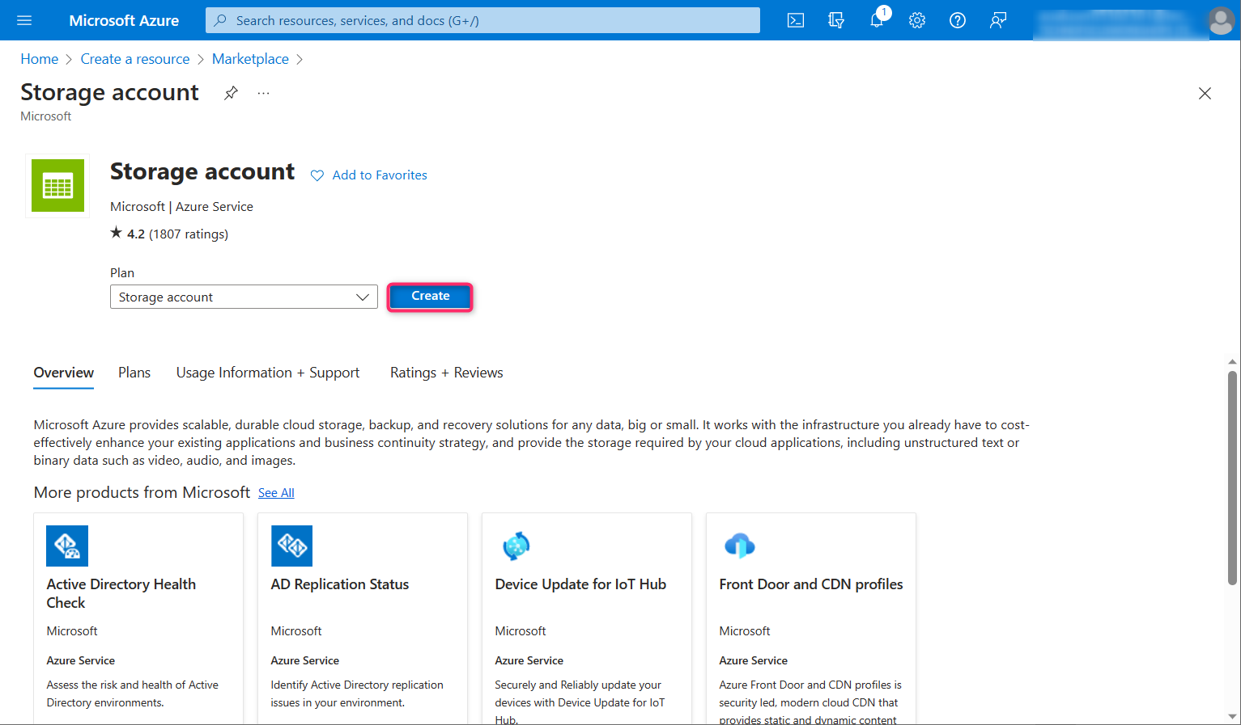

1. On **Create a storage account** window, under the **Basics** tab, enter the below details to create a storage account and then click on **Review**

| **Subscription** | **Select the assigned subscription** |
| --- | --- |
| **Resource group** | Select your **Resource group**(that you have created in Lab 1) |
| **Storage account name** | **azureopenaistorageXX**(XX can be a unique number) (here, we entered **azureopenaistorage39**) |
| **Region** | **East US** |
| **Performance** | **Standard:** Recommended for most scenarios (general-purpose v2 account) |
| **Redundancy** | **Locally-redundant storage (LRS)** |

1. 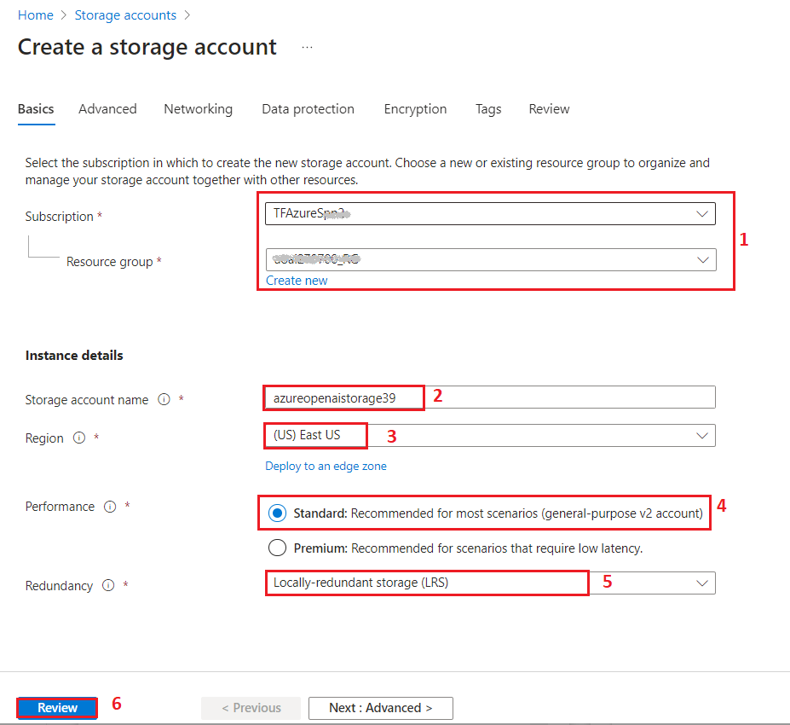
2. On the Review tab, click on the **Create** button.

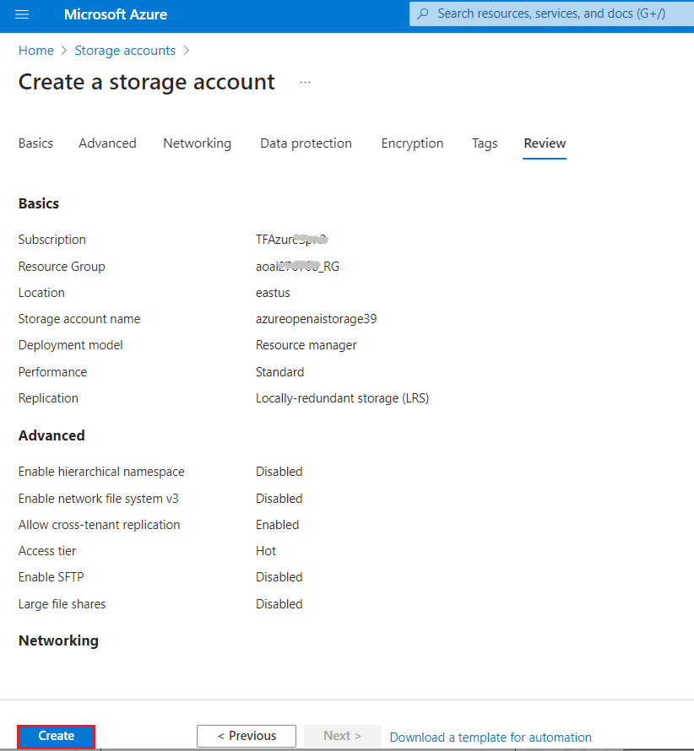

1. This new Azure Storage account is now set up to host data for an Azure Data Lake. Click on the **Go to resource** button.

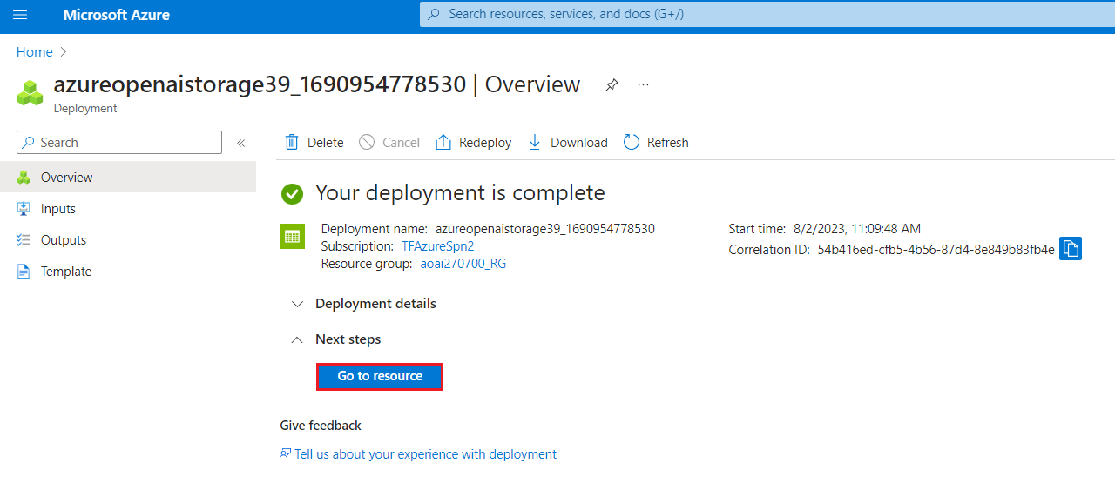

1. After the account has been deployed, you will find options related to Azure Data Lake in the Overview page. In the left-side navigation pane, navigate to **Data storage** section, then click on **Containers**.

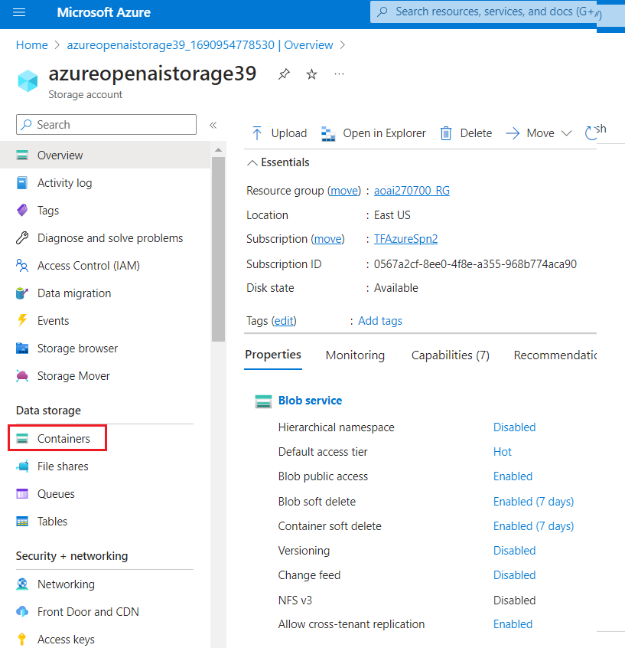

1. On **azureopenaistorageXX | Containers** page, click on **+Container.**

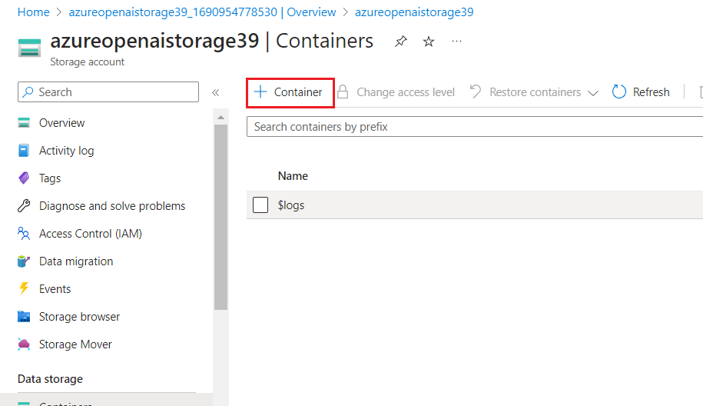

1. On the New container pane that appear on the right side, enter the container **Name** as **source** and click on **Create** button.

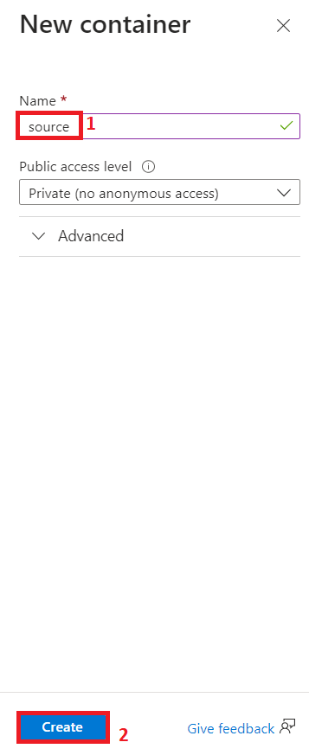

1. On **azureopenaistorageXX | Containers** page, select **source** container.

1. On **source** container page, click on **Upload** button.

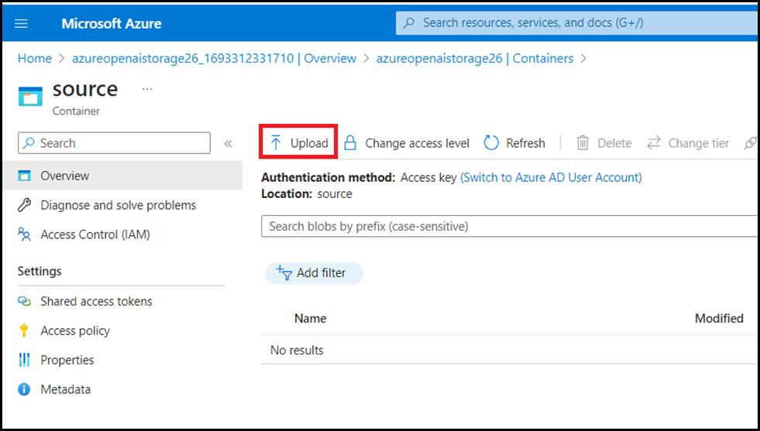

1. In the **Upload blob** pane, click on **Browse for file**, navigate to **C:\Labfiles** location and select **TF-AzureOpenAI.pdf**, then click on the **Open** button.

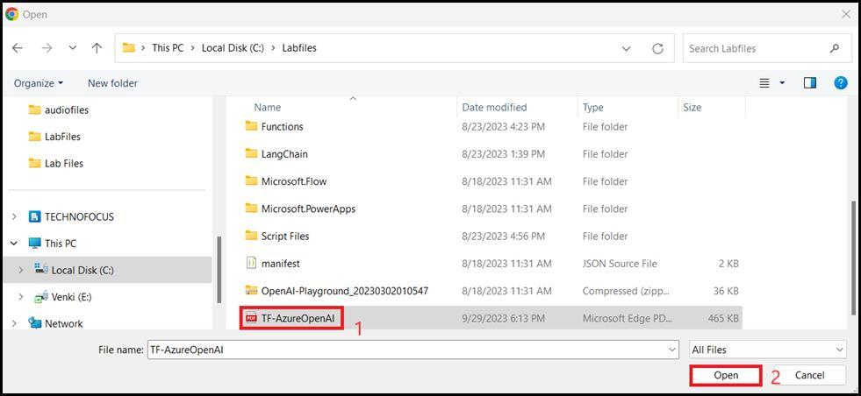

1. In **Upload blob** pane, click on the **Upload** button.

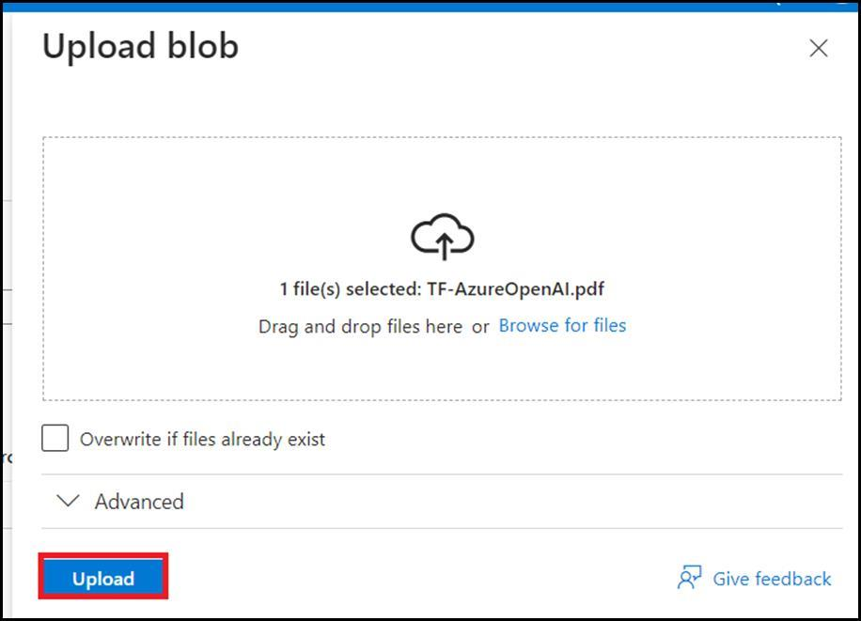

1. You will see a notification – **Successfully uploaded blob** when the uploaded is succeeded.

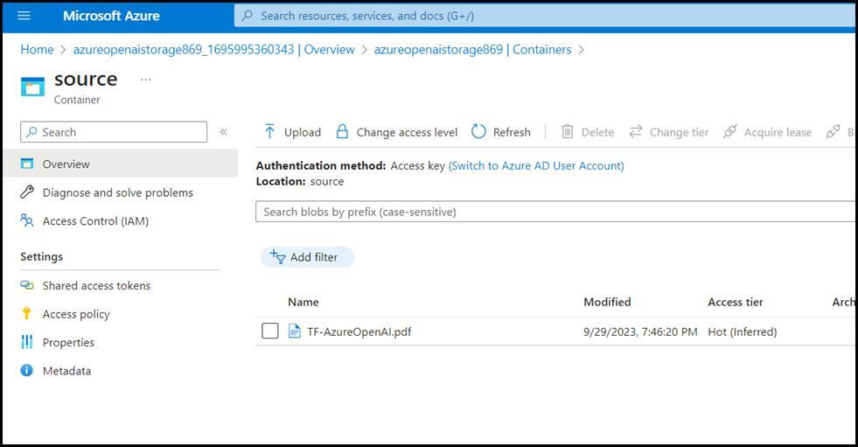

**Task 3: Create an Azure Cognitive Search service in the portal**

1. On the **azureopenaistorageXX | Containers** page, click on **Home** to go back to Azure portal home page.

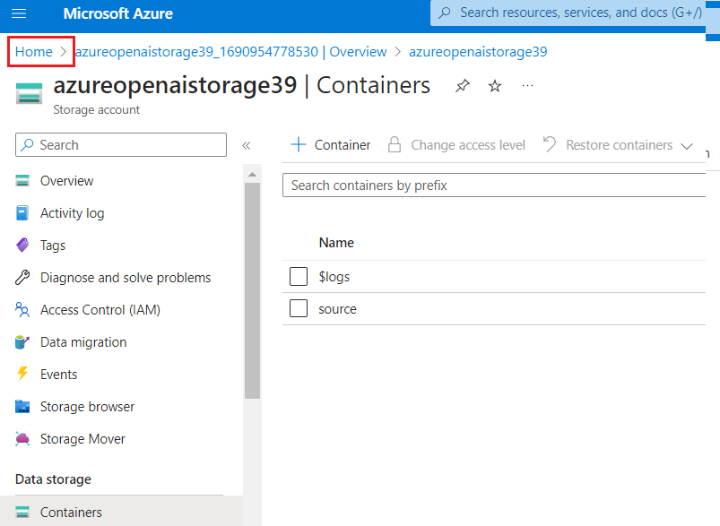

1. In Azure portal home page, click on **+ Create Resource**.

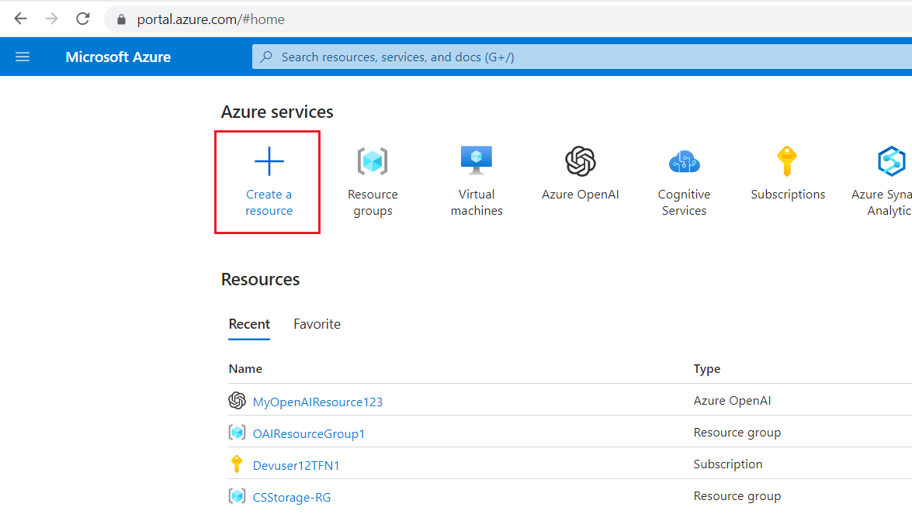

1. In the **Create a resource** page search bar, type **Azure AI Search** and click on the appeared **azure ai search**.

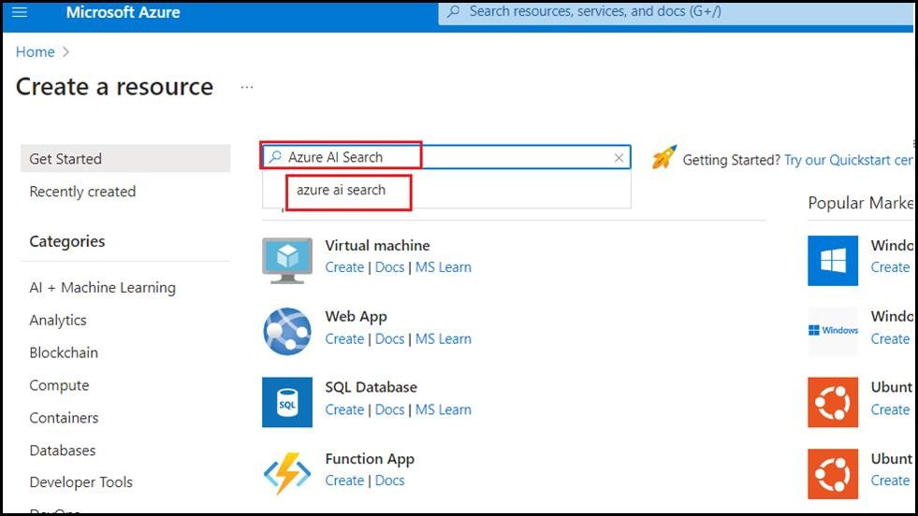

1. Click on **Azure ai Search** section.

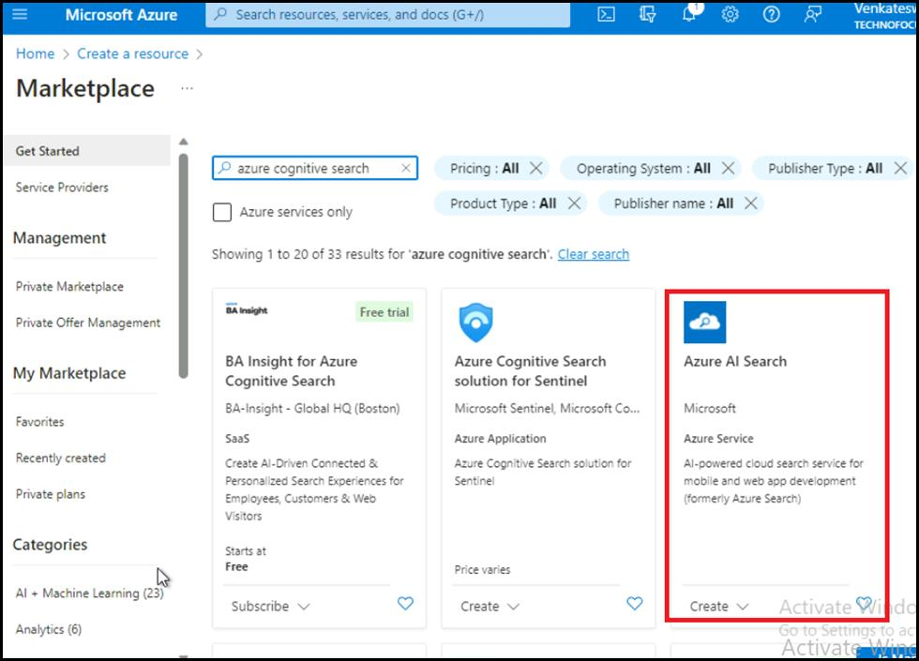

1. In the **Azure AI Search** page, click on the **Create** button.

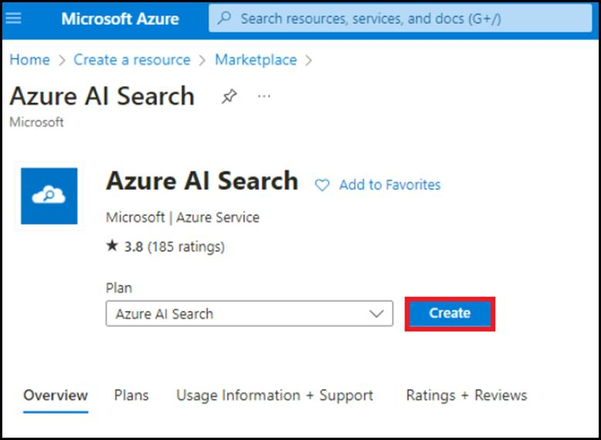

1. On the **Create a search service** page, provide the following information and click on **Review+create** button.

| **Field** | **Description** |
| --- | --- |
| **Subscription** | Select the subscription assigned to |
| **Resource group** | Select your **Resource group**(that you have created in Lab 1) |
| **Region** | EastUS |
| **Name** | **mysearchserviceXX** (XXcan be unique number) |
| **Pricing Tier** | Click on change Price Tire>select **Basic** |

1. 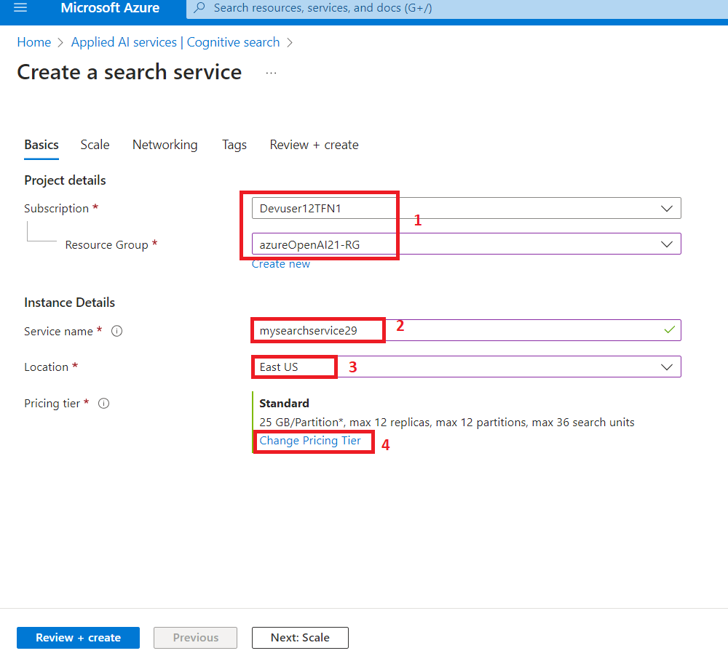
2. 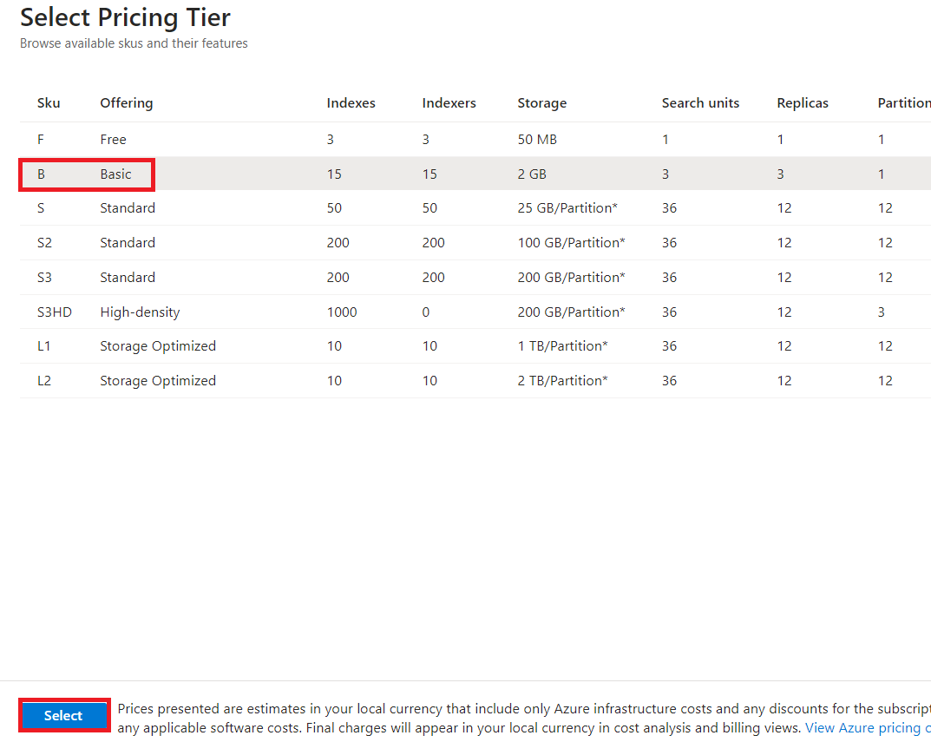
3. 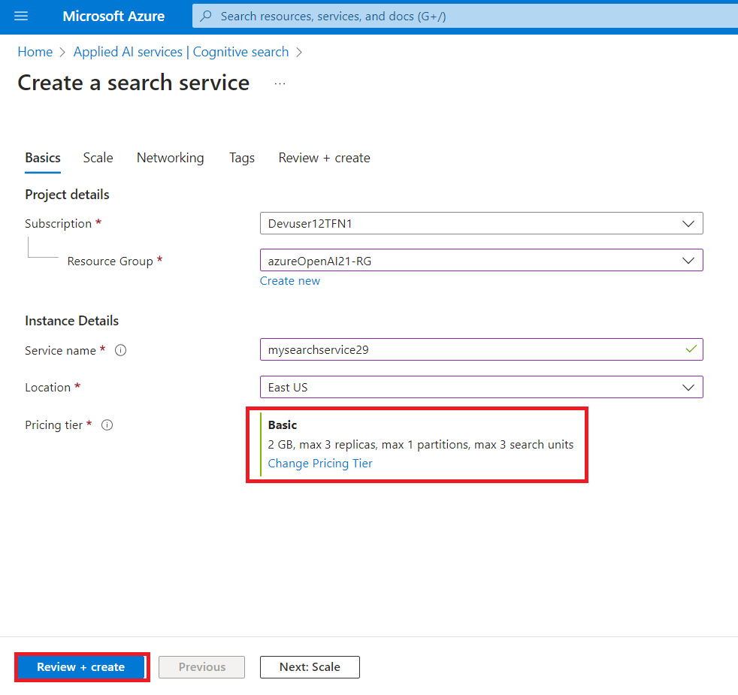
4. Once the Validation is passed, click on the **Create** button.

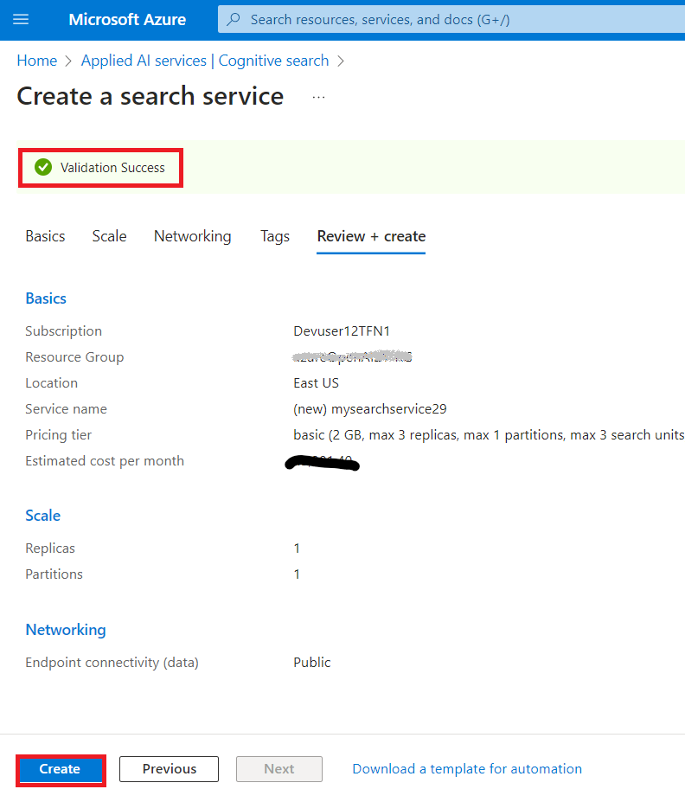

1. Once the deployment is completed, click on **Go to resource group** button.

1. In the **mysearchserviceXX** Overview page. In the left-side navigation pane, under **Settings** section, select **Semantic ranker**.

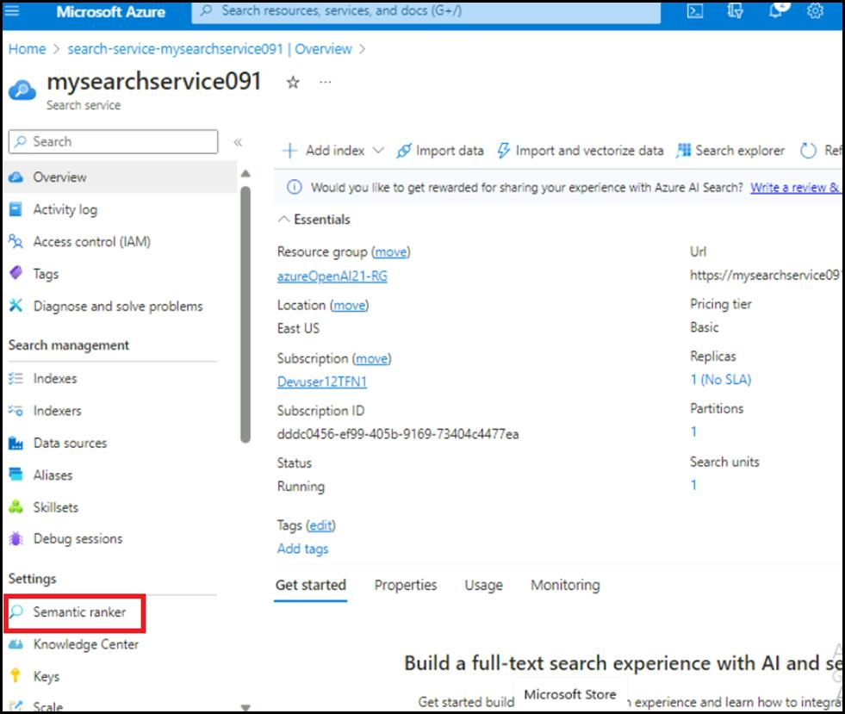

1. On the **Semantic ranker** tab, select **Free** tile and click on the **Select plan**.

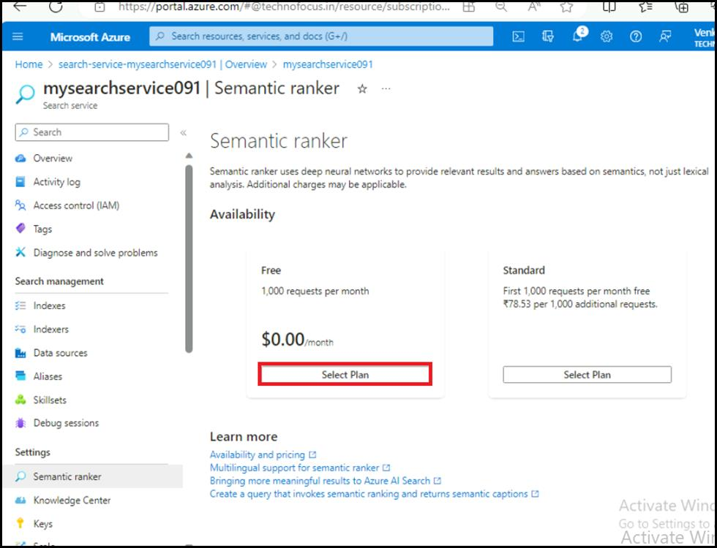

1. You will see a notification - **Successfully updated semantic ranker to free plan**.

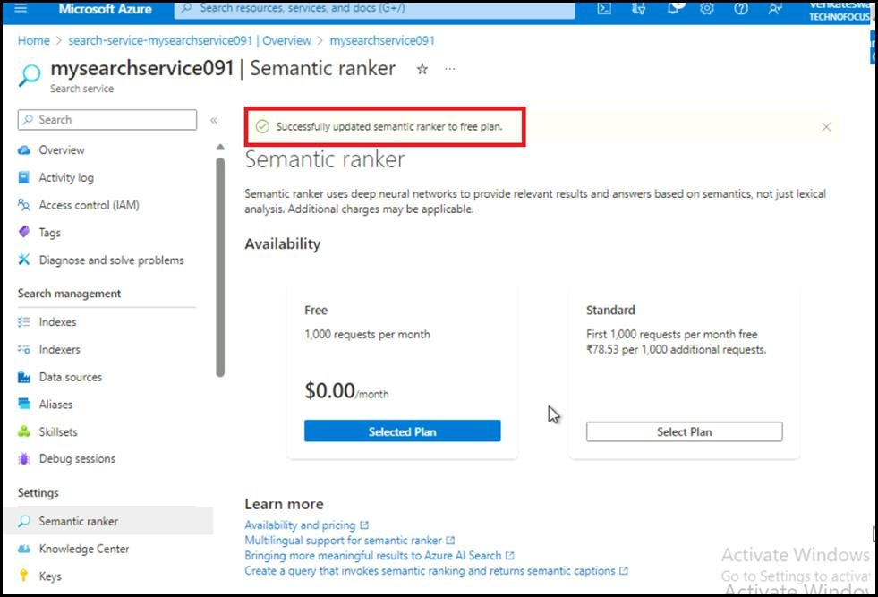

**Exercise-2: Add your data using Azure OpenAI Studio**

**Task 1: Deploy gpt-3-turbo model in Azure AI Studio**

1. Open your browser, navigate to the address bar, and type or paste the following URL: **https://oai.azure.com/)** then press the **Enter** button.

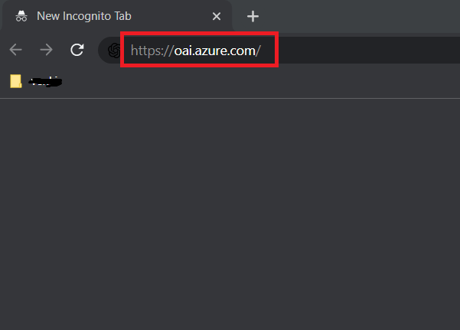

**Note:** If you are directed to the Azure OpenAI Studio home page, then skip steps from #2 to #4, else continue.

1. In the **Microsoft Azure** window, enter your **Sign-in** credentials, and click on the **Next** button.

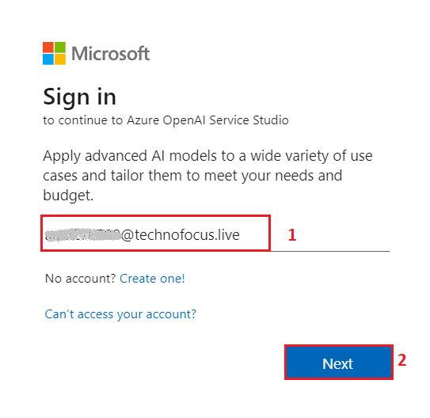

1. Then, enter the password and click on the **Sign in** button.

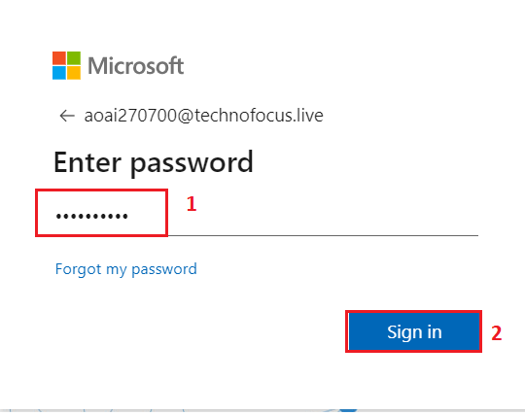

1. In **Stay signed in?** window, click on the **Yes** button.

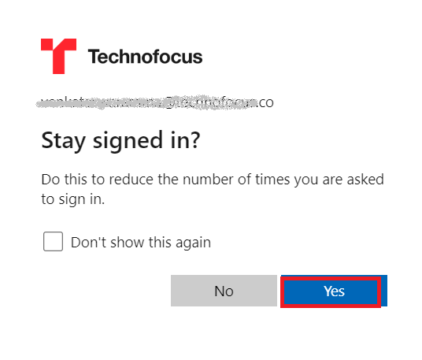

1. On the **Welcome to Azure OpenAI Studio** dialog box, under the **Subscription** field, enter the subscription assigned to you, and in the **Resource** field, select the existing Resource name that you’ve created in Lab #1, and then click on the **Use resource** button.

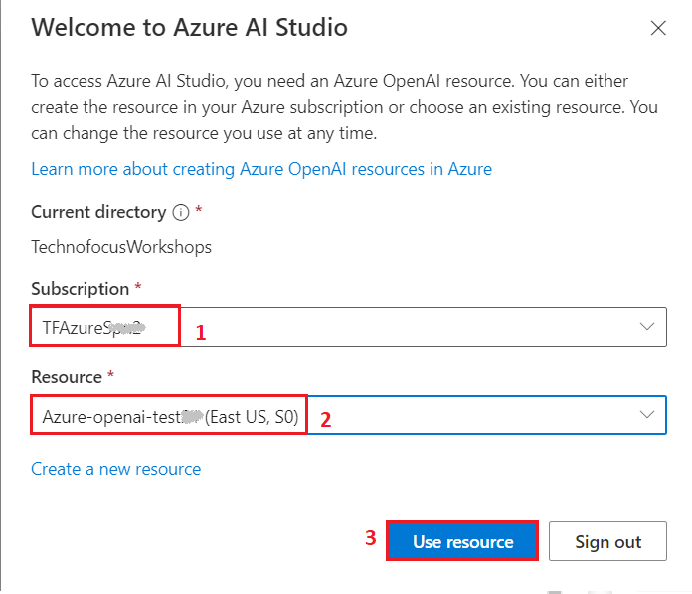

1. Wait for the **Azure AI Studio** to launch.

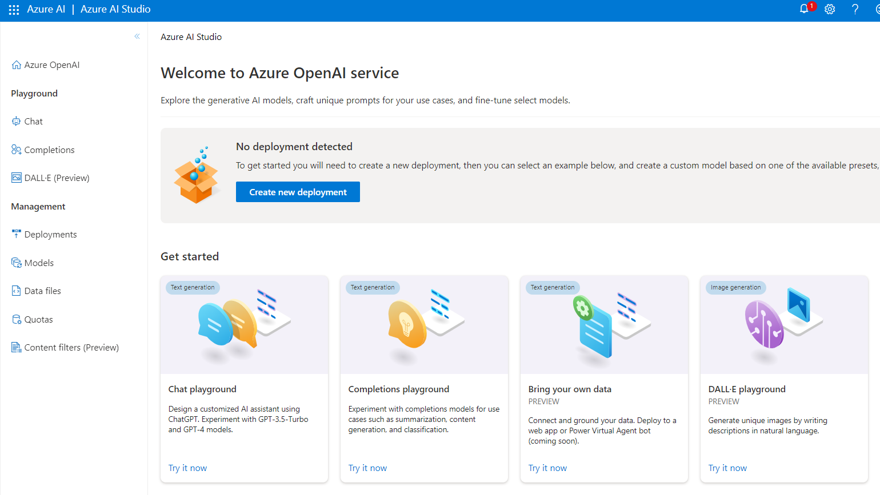

1. On the **Azure AI Studio** homepage, click on **Create new deployment** button.

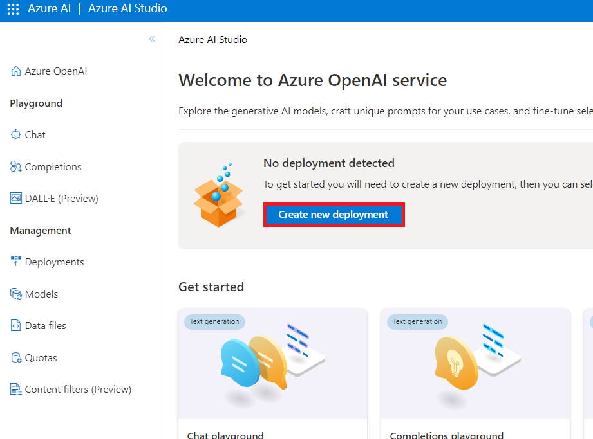

1. In the **Deployments** page, click on +**Create new deployment**.

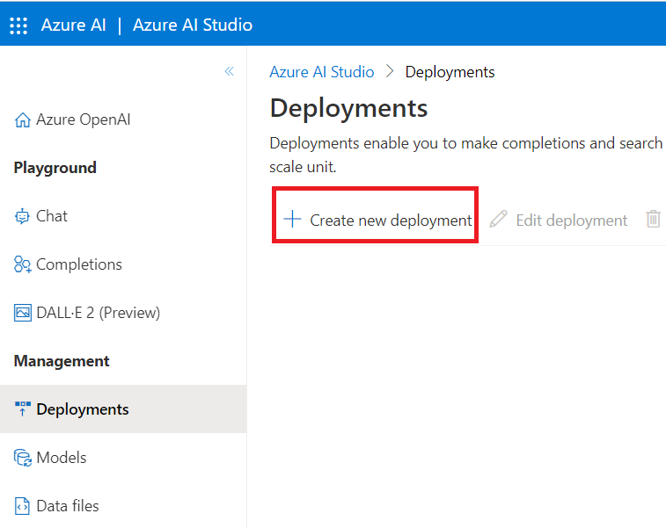

1. In the **Deploy model** dialog box, under **Select a model** click on the dropdown select **gpt-35-turbo** field, under **Model version** select **0301** and under **Deployment name** enter **gpt-35-turbo0301**. Click on the **Create** button.

1. You will see a notification – **Successfully Created deployment** when the deployment is succeeded. (You can also view the notification by clicking on the bell icon beside **Azure AI | Azure AI Studio**).

1. In the **Deployments** page, click on **+Create new deployment**.

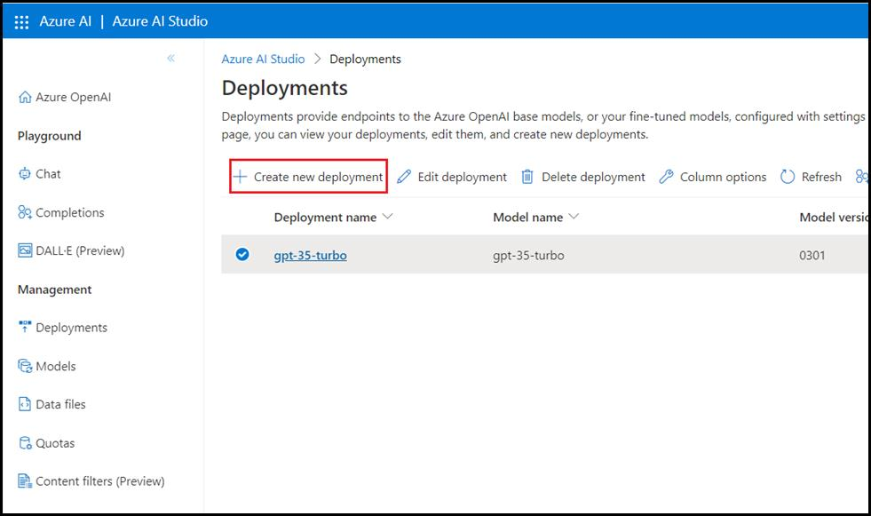

1. In the **Deploy model** dialog box, under **Select a model** click on the dropdown select **text-embedding-ada-002** field, under **Model version** select 2(Default) and under **Deployment name** enter !! text-embedding-ada-002!!. Click on the **Create** button.

1. You will see a notification – **Successfully Created deployment** when the deployment is succeeded. (You can also view the notification by clicking on the bell icon beside **Cognitive Services | Azure OpenAI Studio**).

**Important:** We strongly recommend using text-embedding-ada-002 (Version 2). This model/version provides parity with OpenAI's text-embedding-ada-002. To learn more about the improvements offered by this model, please refer to OpenAI's blog post. Even if you are currently using Version 1, you should migrate to Version 2 to take advantage of the latest weights/updated token limit.

**Task 2: Add your data using Azure OpenAI Studio**

1. Click on the **Azure OpenAI** home icon to go back to the home page.

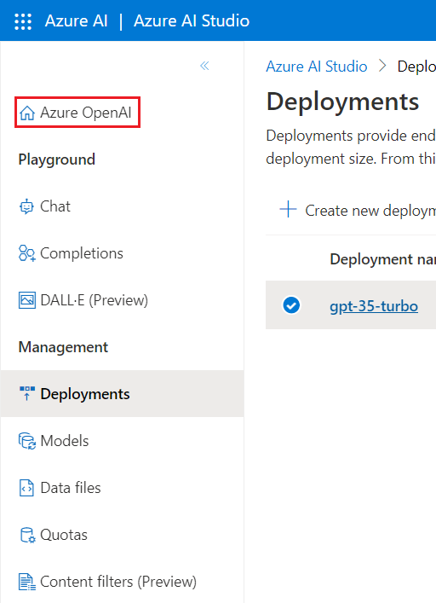

1. In Azure OpenAI Studio Home page, under **Welcome to Azure OpenAI Service**, click on the **Bring your own data**

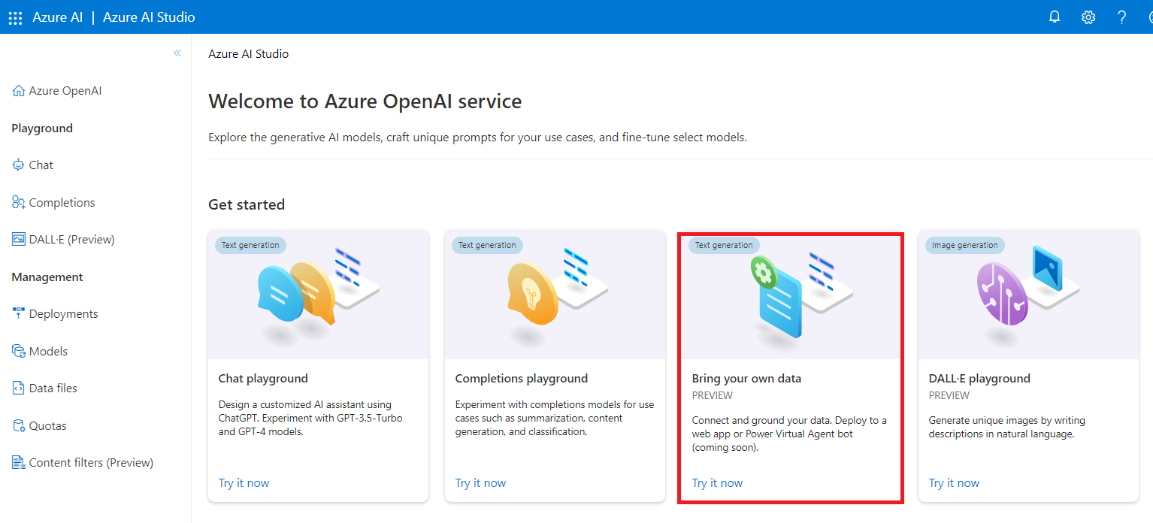

1. In the **Add data** page, click on the dropdown under **Select or add data source**, then navigate and click on **Azure Blob Storage**.

1. In the **Add data** page, under **Select or add data source** enter the following details and select **Next**.

| **Subscription** | **Select your Azure OpenAI subscription** |
| --- | --- |
| **Select Azure Blob storage resource** | Select your Azure Blob storage that you have created in Exercise 1 Task 2(**azureopenaistorageXX**) |
| **Select storage container** | source |
| **Select Azure AI Search resource** | Select your Azure AI Search that you have created in Exercise 1 Task 3(**mysearchserviceXX**) |
| **Enter the index name** | azure-index |
| **Indexer schedule** | Hourly |

1. Select the check box – **Add vector search to this search resource**.
2. Select an embedding model as **text-embedding-ada-002**, then click on the **Next** button.

**Note:** In case, you encounter an error – **Can‘t manage CORS on this resource. Please select another storage resource**, then syn your VM time, as mentioned in Lab #1, Task #1.

1. Select the check box – **I acknowledge that connecting to an Azure Cognitive Search account will incur usage to my account**
2. In the **Add data** page, on the **Data management** tab drop down the Search type and select **Hybrid+semantic**.
3. **Select the check box**- I acknowledge that using semantic search will incur usage to my Azure Cognitive Search account.
4. Select the default chunk size as **1024**.
5. **Select the check box**-I acknowledge that adding vector embeddings will incur usage to my account. Then, click on **Next**.

1. In **Review and Finish** pane, review the details that you’ve entered, and click on **Save and close** button.

1. The data will be added in your Chat Playground. This will take approximately 4-5 minutes.

**Task 3: Explore text completion in the Chat Playground**

1. In the **Chat session** section, enter the following prompt in the **User message** text box and click on the **Send** icon

**CodeCopy**

**What is Azure OpenAI Service?**

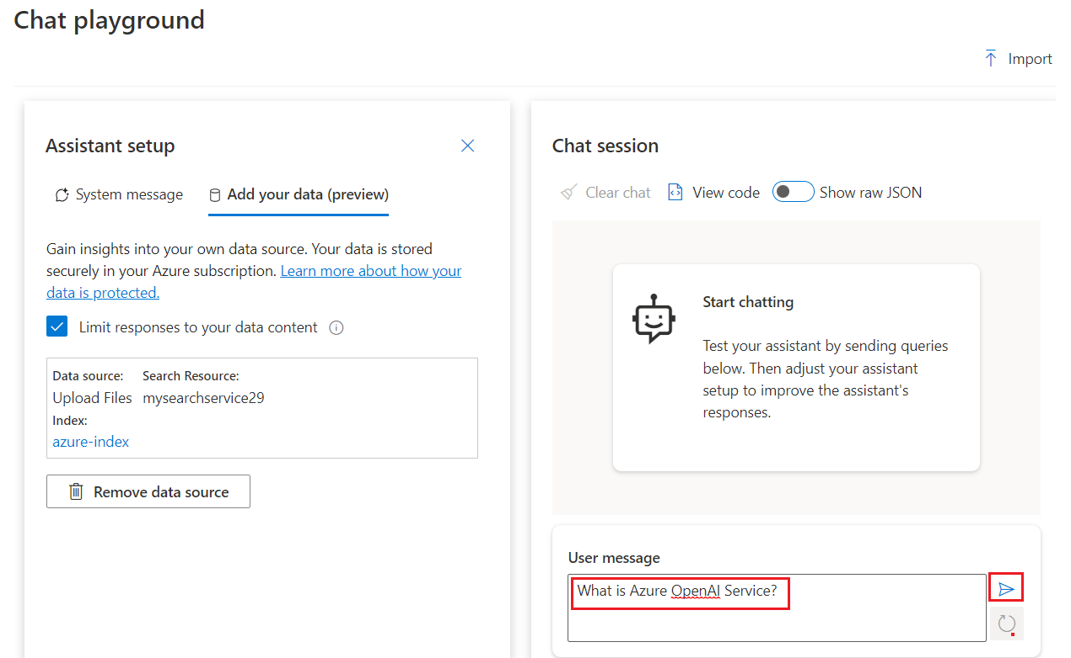

1. In the **Chat session** section, select the references link and observe the details of search document on right side of the page.

1. Send the following prompt to the model by pasting them in **User message** text box and clicking on the **Send** icon.

**CodeCopy**

**How do I get access to Azure OpenAI?**

1. In the **Chat session** section, select the references link and observe the details of search document on right side of the page.

**Exercise 3: Deploy a web app with custom data**

**Task 1: Deploy a web app**

1. Open your browser, navigate to the address bar, and type or paste the following URL: https://oai.azure.com/then press the **Enter** button.
2. In Azure AI Studio **Chat playground**, click on the V chevron button beside **Deploy to**, then navigate and click on **A new web app**.

**Note:** In case, you did not see **Deploy to** button on your VM, then use Ctrl+- or Ctrl+minus keyboard shortcut to zoom out and decrease the font size.

1. On **Deploy to a web app** window, select **Create a new web app** radio button and enter the following details:

| **Property** | **Value** |
| --- | --- |
| Name | **AOAI-webappXXX**(XXX can be a unique number) (here, we entered AOAI-webapp129) |
| Subscription | Select the assigned subscription |
| Resource Group | Select the resource group created in Lab 1 |
| Location | **East US** |
| Pricing plan | **Standard(S1)** |

1. Select the check box of **I acknowledge that web apps will incur usage to my account**, then click on **Deploy** button.

1. Wait for the deployment to complete. The deployment will take around 10-15 minutes.

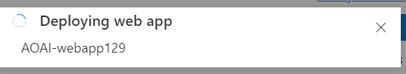

1. After successful deployment of the web app, you’ll will see a notification – **Web app deployed**. (You can also view the notification by clicking on the bell icon beside **Azure AI | Azure AI Studio**).

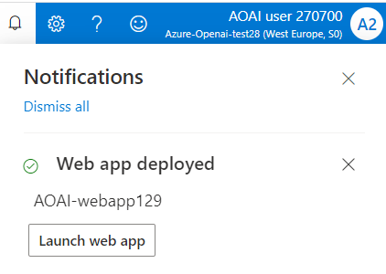

1. On the right side of **Chat playground**, click on **Launch web app** button.

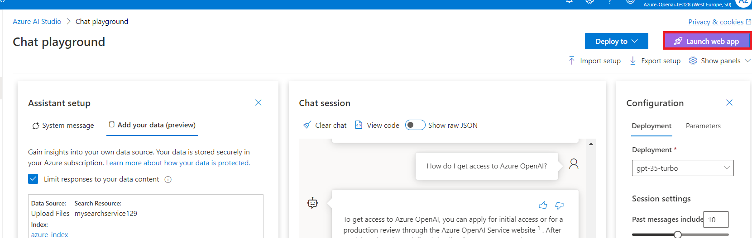

1. Wait for 10 minutes, so that authentication configuration can be successfully applied on the app.

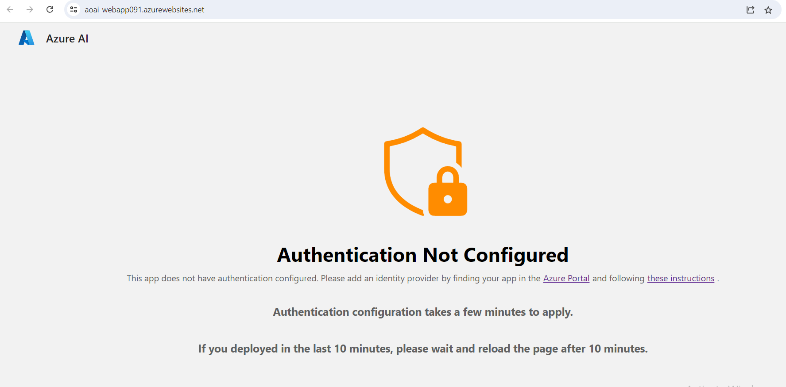

1. After 10 minutes click on the **Refresh** button.

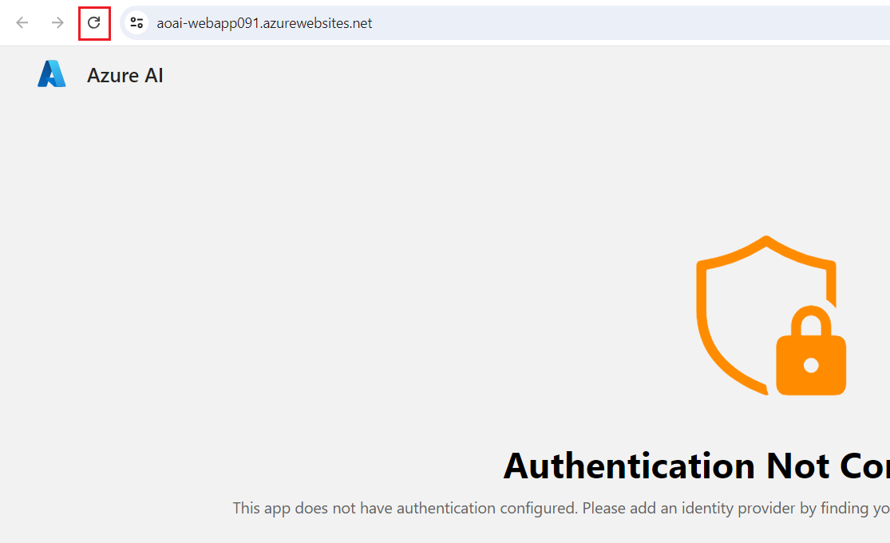

1. On **Permissions requested** dialog box, click on the **Accept** button

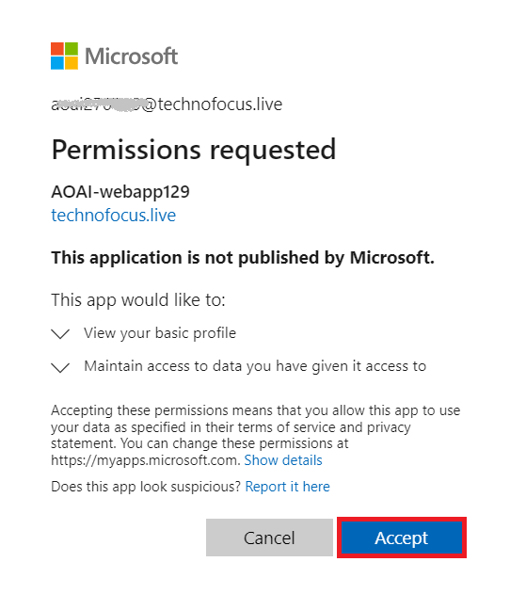

1. Now, web app will open in a new browser.

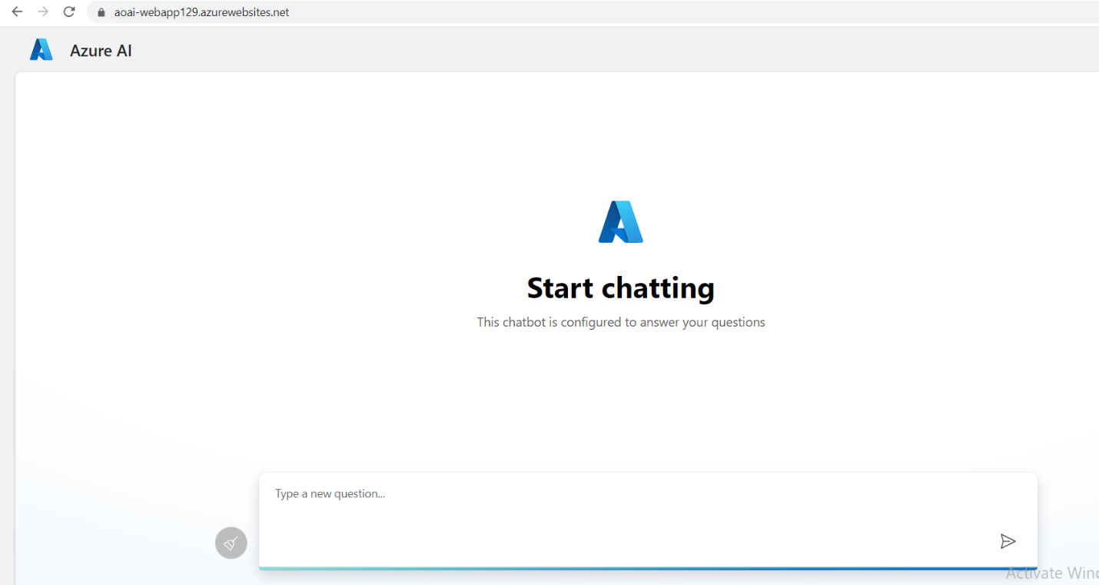

1. In the **Azure AI** web app page, enter the following text and click on the **Submit icon** as shown in the below image.

**CodeCopy**

**How do I get access to Azure OpenAI?**

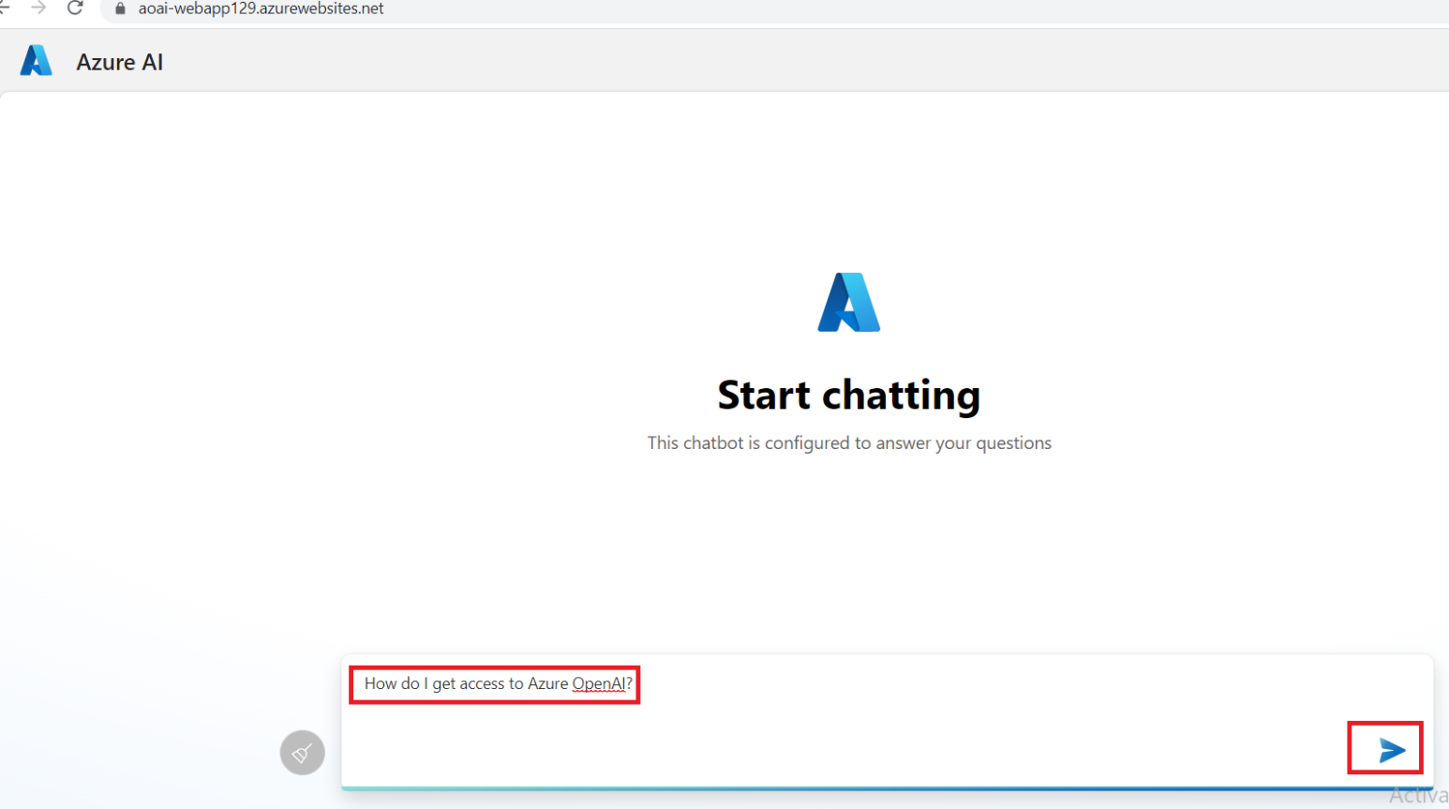

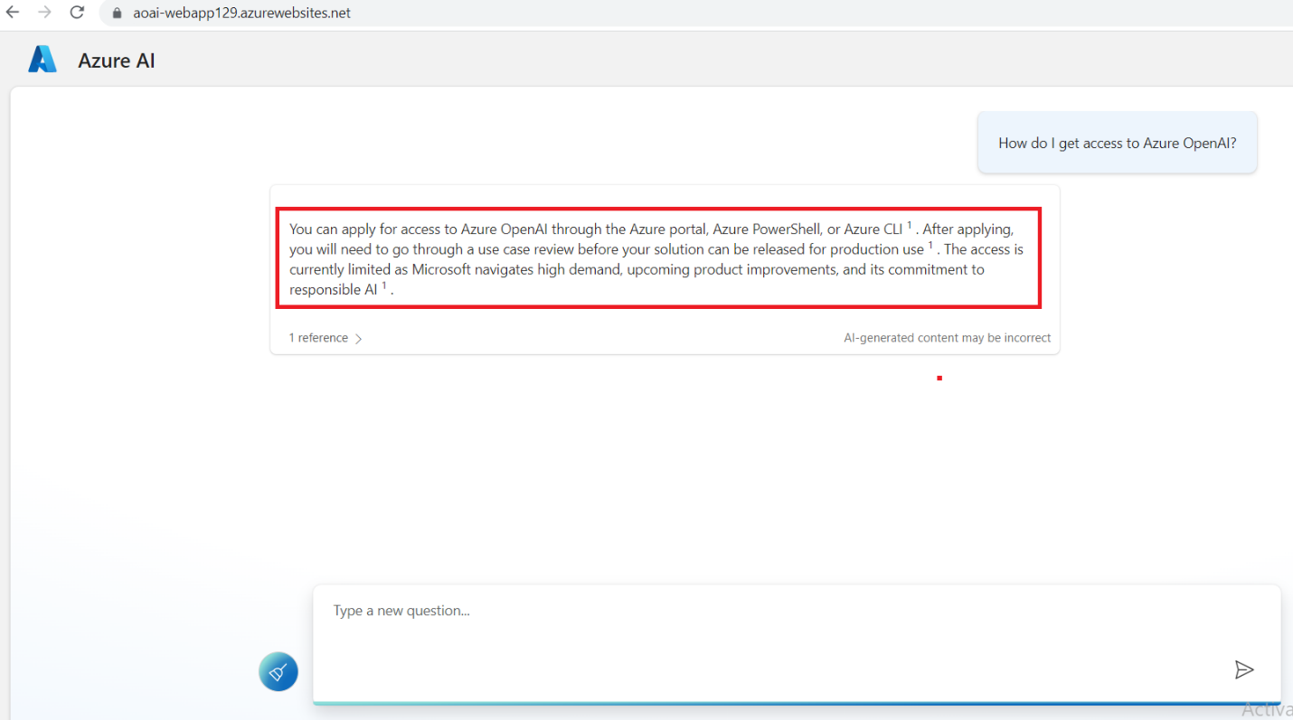

1. In case, you did not see **Python developers**, click on the **Refresh** button

1. Similarly, paste the following text in the text box and click on the **Send** icon.

**CodeCopy**

**What is the expiry date of GPT-35-Turbo version 0301 and GPT-4 version 0314?**

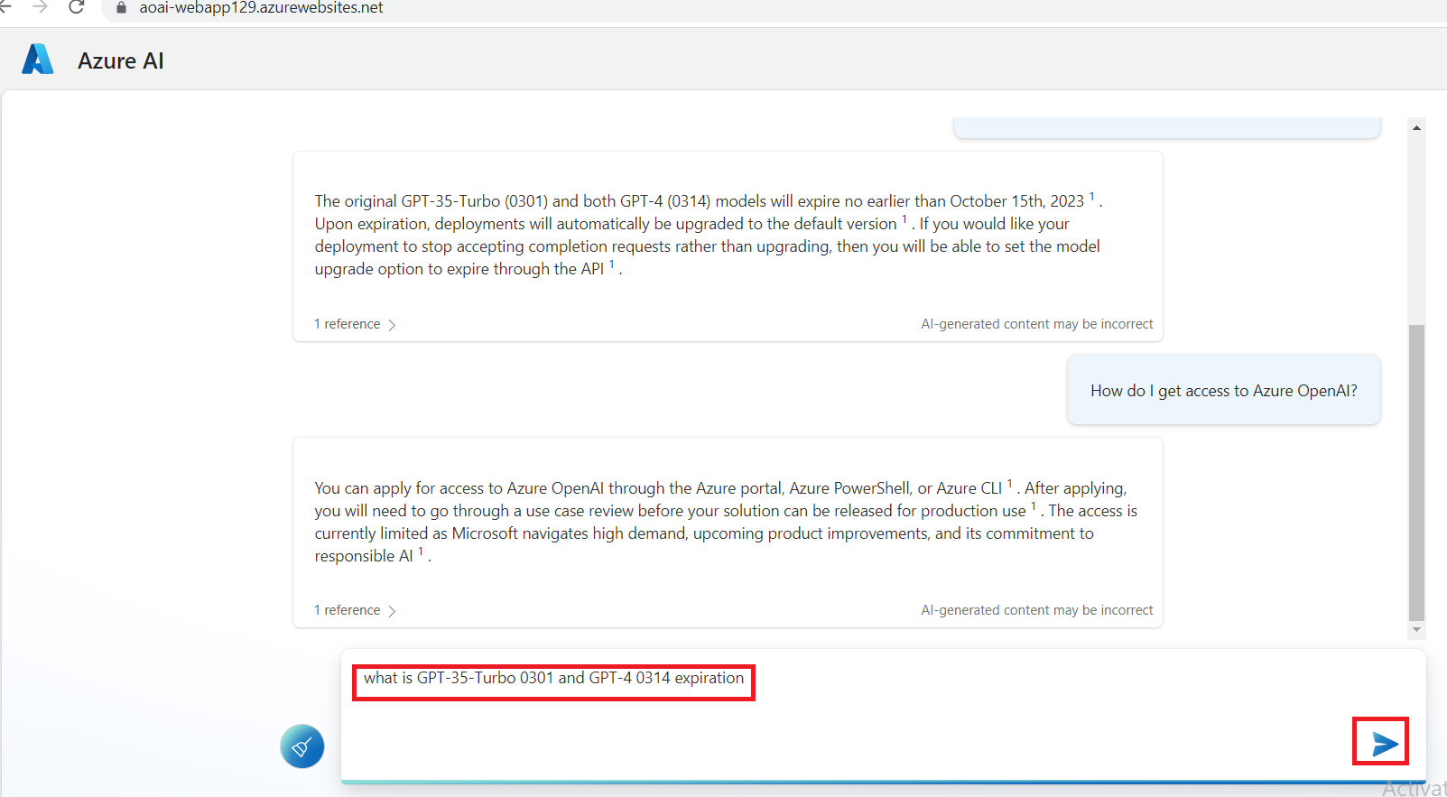

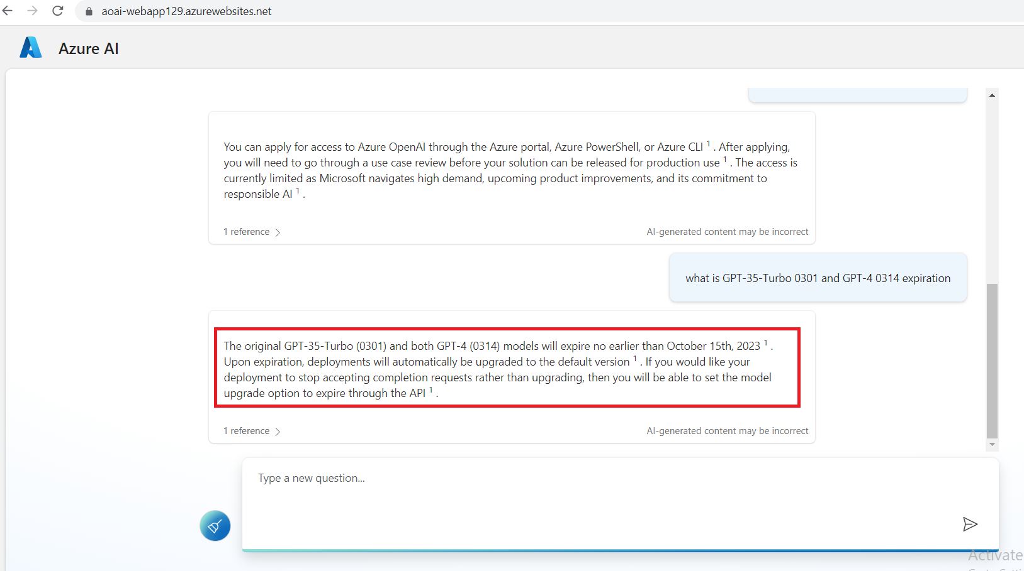

**Task 2: Delete the deployed model**

1. In Azure OpenAI Studio, on the left pane, under the **Management** section, click on **Deployments**.

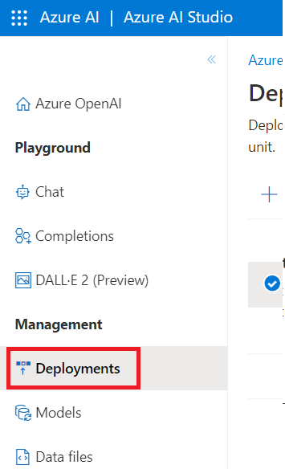

1. Select **gpt-35-turbo0301** deployment name and click on **Delete deployment**.

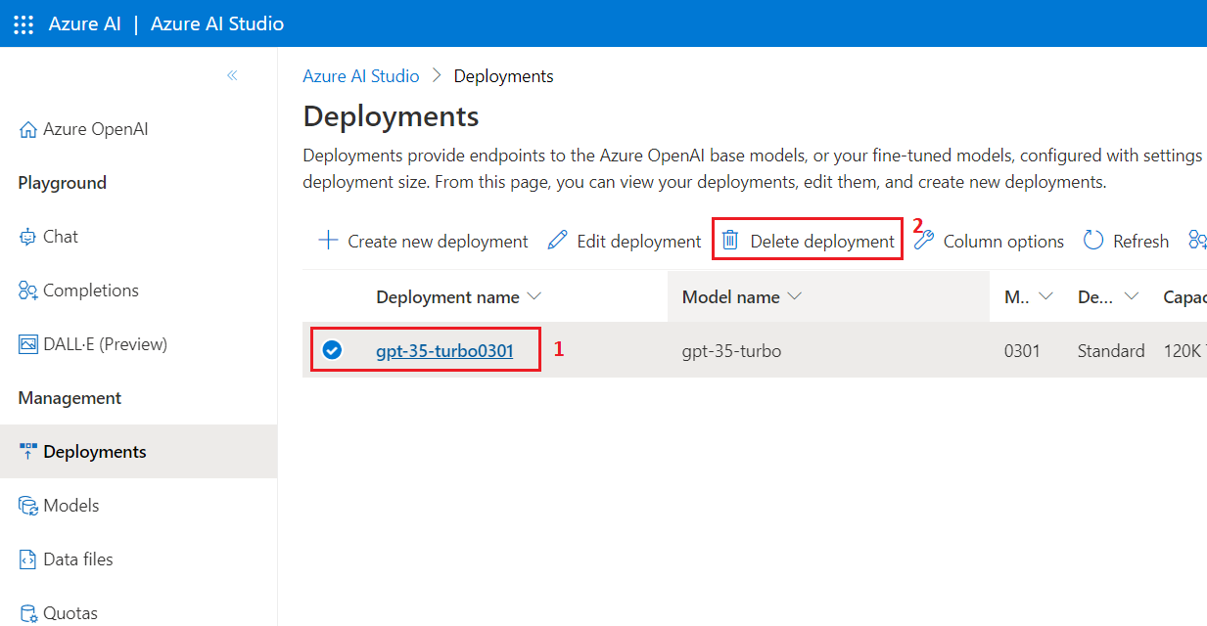

1. In the **Confirm delete** dialog box, click on the **Delete** button. You will see the notification – **Successfully Deleted deployment** (In case, you did not see the notification, then click on the bell icon beside **Azure AI|Azure AI Studio**).

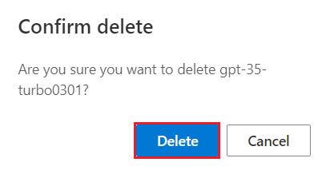

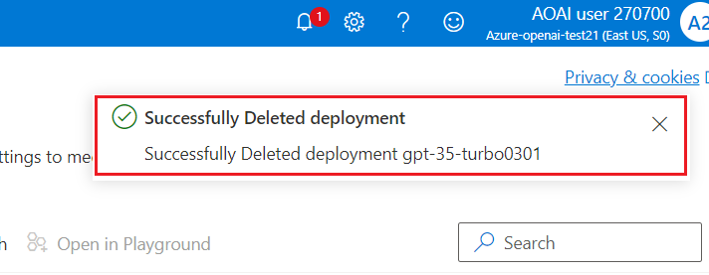

1. In Azure OpenAI Studio, on the left pane, under the **Management** section, click on **Deployments**.

1. Select **text-embedding-ada-002** deployment name and click on **Delete deployment**.

1. In the **Confirm delete** dialog box, click on the **Delete** button. You will see the notification – **Successfully Deleted deployment** (In case, you did not see the notification, then click on the bell icon beside **Cognitive Services | Azure OpenAI Studio)**.

**Task 3: Delete the Azure storage account, Azure cognitive search and Azure Web app**

1. To delete the storage account, navigate to Azure portal home page, type **Resource groups** in the Azure portal search bar, navigate and click on **Resource groups** under **Services**.

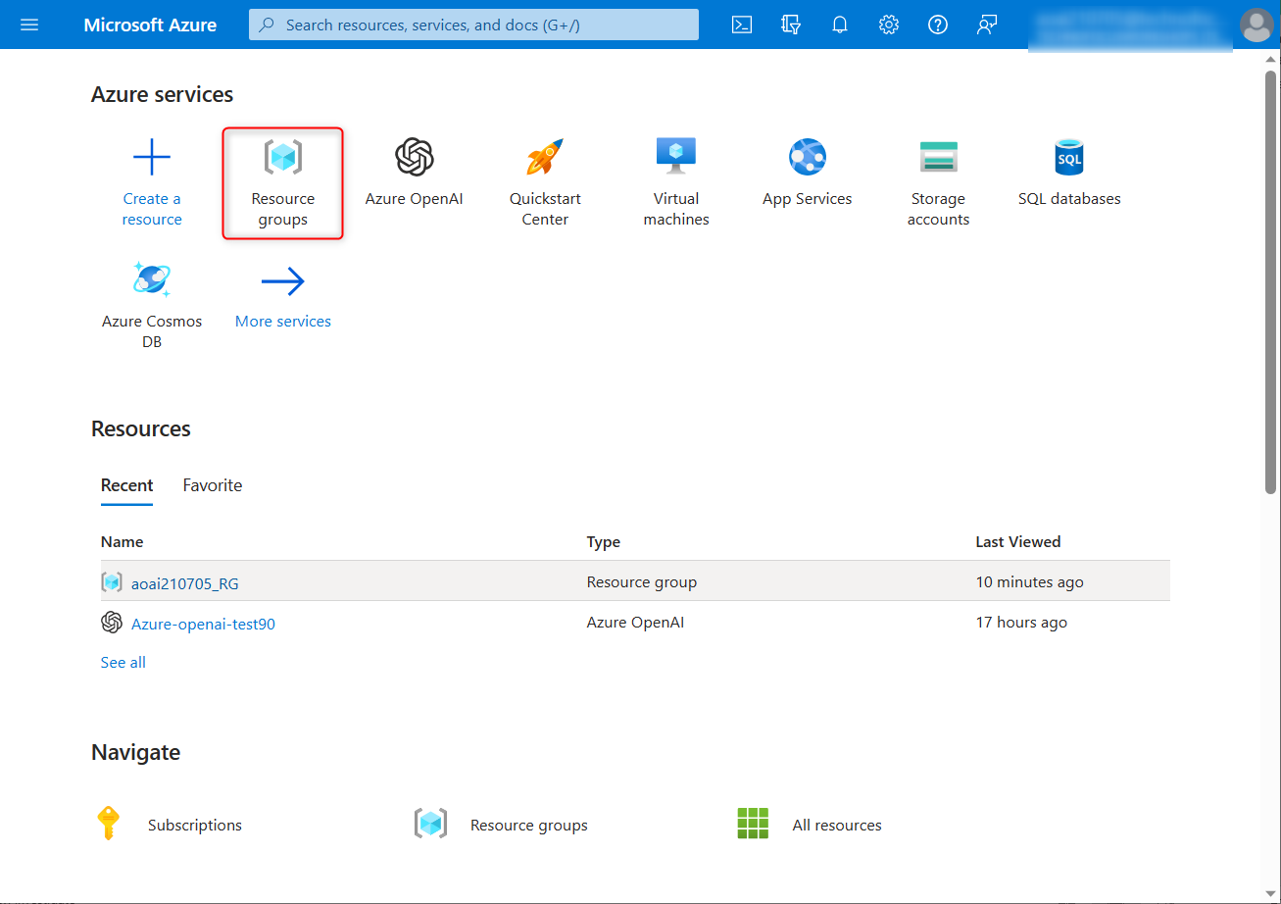

1. Click on the resource group you created in Lab 1.

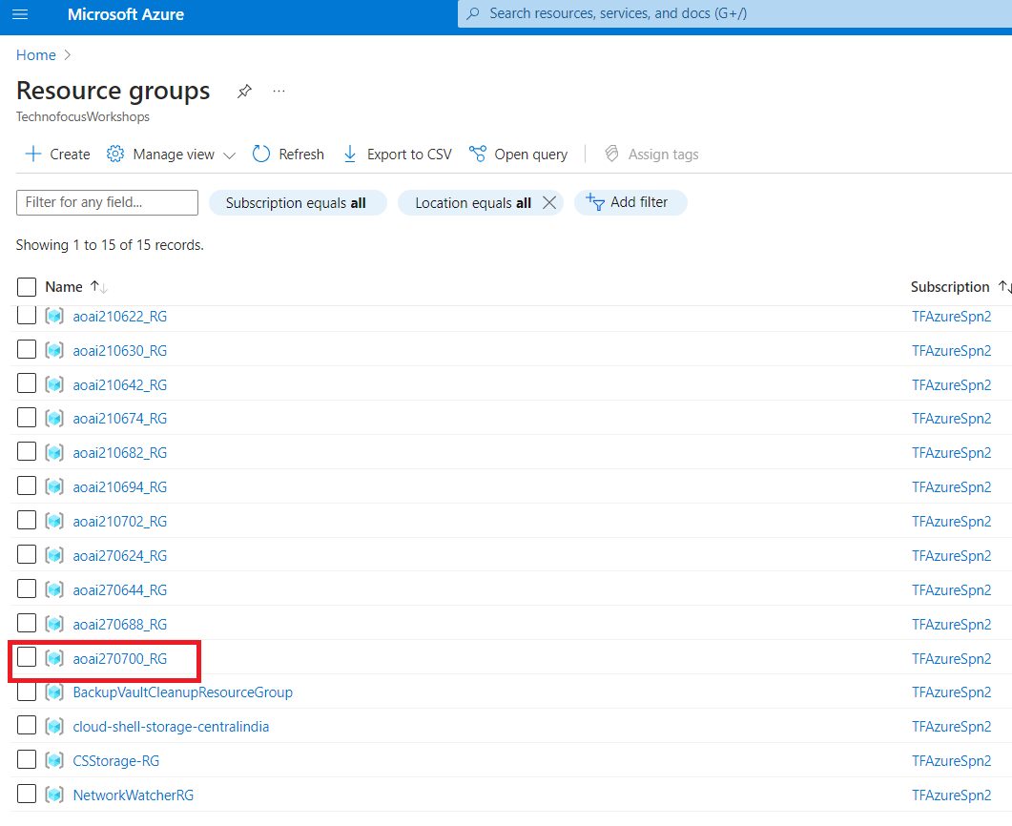

1. Carefully select storage account, Azure Cognitive Search and Azure web app that you’ve created .

**Note:** Don’t select Azure OpenAI service.

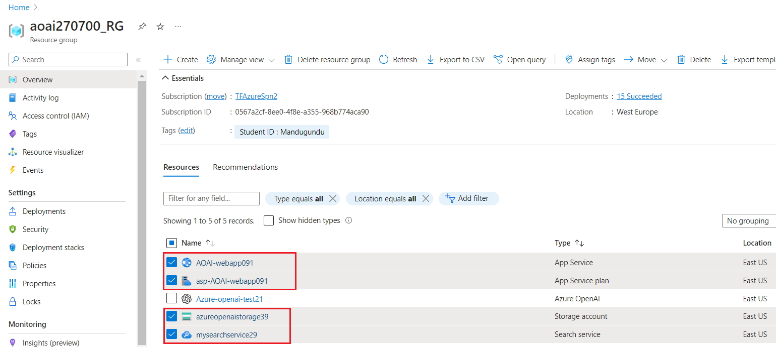

1. In the Resource group page, navigate to the command bar and click on **Delete**.

**Important Note:** Don’t click on Delete resource group. If you don’t see the Delete option in the command bar, then click on the horizontal ellipsis.

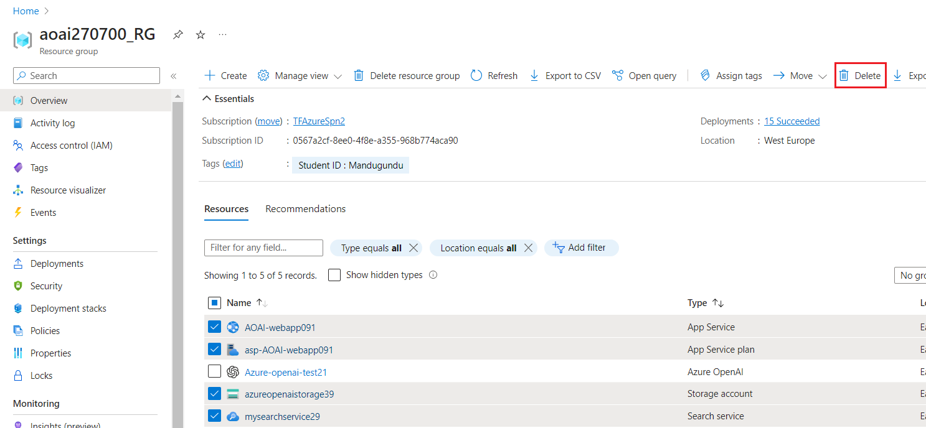

1. In the **Delete Resources** pane that appears on the right side, enter the **delete** and click on **Delete** button.

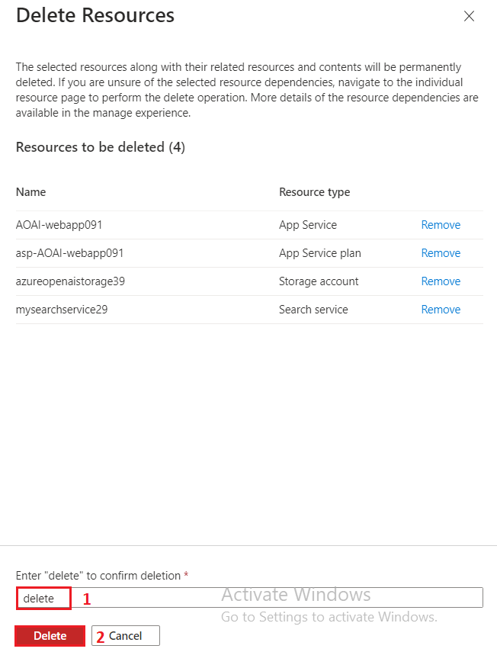

1. On **Delete confirmation** dialog box, click on **Delete** button.

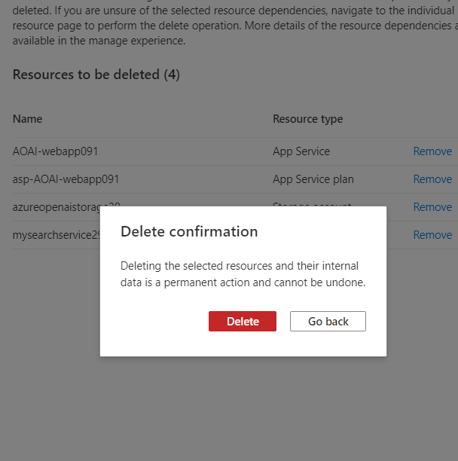

1. Click on the bell icon, you’ll see the notification – **Executed delete command on 4 selected items**

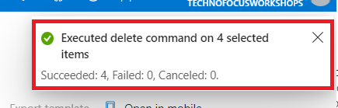

**Summary** You've created a storage account, container, and Azure cognitive service in Azure portal, then you've deployed gpt-3-turbo model in Azure AI Studio. You’ve added data in Chat Playground and tested the Assistant setup by sending queries in a chat session. Then, you've launched a new app and started conversation with the chatbot. You've deleted the gpt-3-turbo model, Azure storage account, cognitive search service, and the new web app to effectively and efficiently manage the Azure OpenAI resources.

**Important Note: Please do not delete the Resource group and Azure OpenAI Service (Azure-openai-testXX). The same Resource group and AOAI service will be used throughout all the labs.**